UNITED STATES
SECURITIES AND EXCHANGE COMMISSION
Washington, D.C. 20549

SCHEDULE 14A
Proxy Statement Pursuant to Section 14(a) of the
Securities Exchange Act of 1934
(Amendment No. )

Filed by the Registrant ☒
Filed by a Party other than the Registrant ☐
Check the appropriate box:

☐ | Preliminary Proxy Statement

☐ | Confidential, for Use of the Commission Only (as permitted by Rule 14a-6(e)(2))

☐ | Definitive Proxy Statement

☒ | Definitive Additional Materials

☐ | Soliciting Material under §240.14a-12
FOGHORN THERAPEUTICS INC.
(Name of Registrant as Specified In Its Charter)
(Name of Person(s) Filing Proxy Statement, if other than the Registrant)
Payment of Filing Fee (Check all boxes that apply):

☒ | No fee required.

☐ | Fee paid previously with preliminary materials.

☐ | Fee computed on table in exhibit required by Item 25(b) per Exchange Act Rules 14a-6(i)(1) and 0-11.

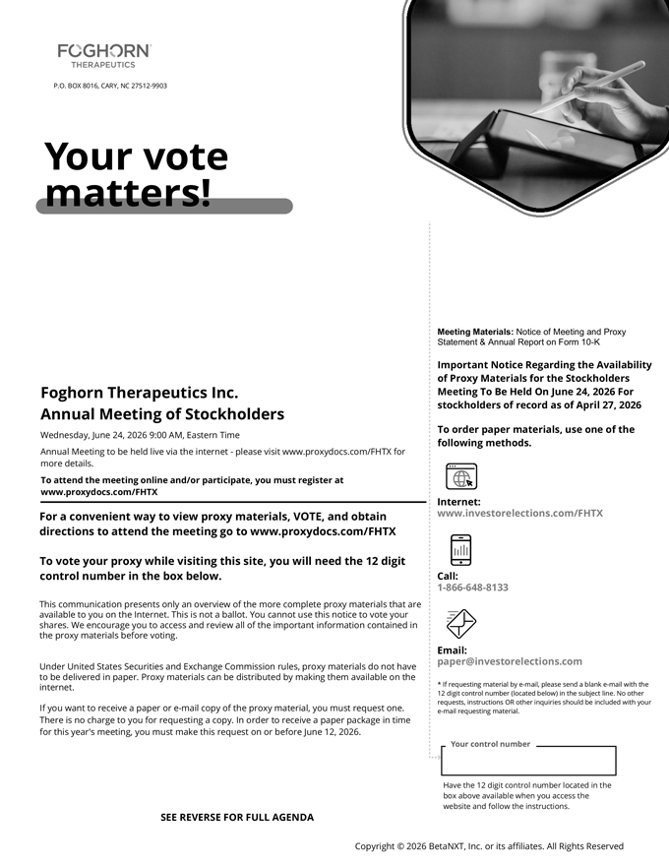
Foghorn Therapeutics Inc. Annual Meeting of Stockholders Wednesday, June 24, 2026 9:00 AM, Eastern Time Annual Meeting to be held live via the internet—please visit www.proxydocs.com/FHTX for more details. To attend the meeting online and/or participate, you must register at www.proxydocs.com/FHTX For a convenient way to view proxy materials, VOTE, and obtain directions to attend the meeting go to www.proxydocs.com/FHTX To vote your proxy while visiting this site, you will need the 12 digit control number in the box below. This communication presents only an overview of the more complete proxy materials that are available to you on the Internet. This is not a ballot. You cannot use this notice to vote your shares. We encourage you to access and review all of the important information contained in the proxy materials before voting. Under United States Securities and Exchange Commission rules, proxy materials do not have to be delivered in paper. Proxy materials can be distributed by making them available on the internet. If you want to receive a paper or e-mail copy of the proxy material, you must request one. There is no charge to you for requesting a copy. In order to receive a paper package in time for this year’s meeting, you must make this request on or before June 12, 2026. Meeting Materials: Notice of Meeting and Proxy Statement & Annual Report on Form 10-K Important Notice Regarding the Availability of Proxy Materials for the Stockholders Meeting To Be Held On June 24, 2026 For stockholders of record as of April 27, 2026 To order paper materials, use one of the following methods. Internet: www.investorelections.com/FHTX Call: 1-866-648-8133 Email: paper@investorelections.com * If requesting material by e-mail, please send a blank e-mail with the 12 digit control number (located below) in the subject line. No other requests, instructions OR other inquiries should be included with your e-mail requesting material. Have the 12 digit control number located in the box above available when you access the website and follow the instructions.

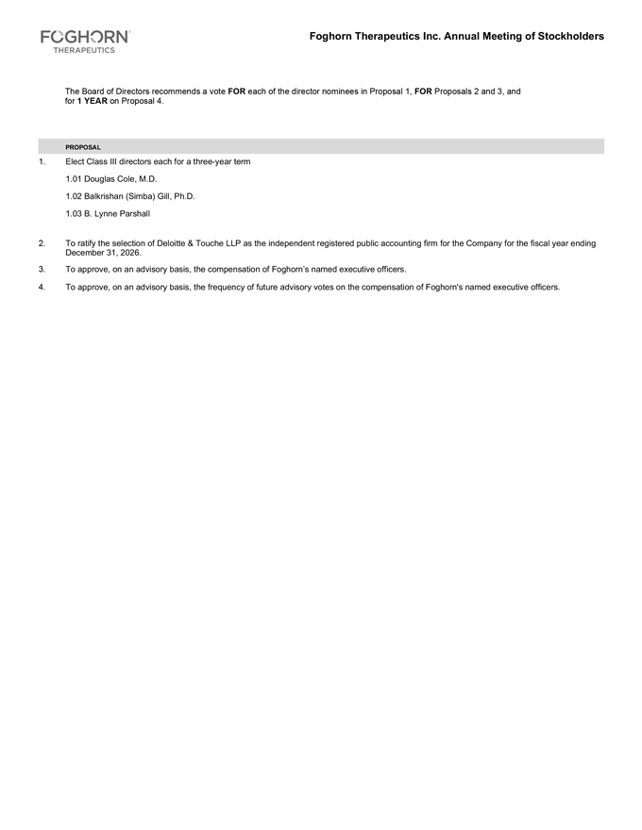
Foghorn Therapeutics Inc. Annual Meeting of Stockholders The Board of Directors recommends a vote FOR each of the director nominees in Proposal 1, FOR Proposals 2 and 3, and for 1 YEAR on Proposal 4. PROPOSAL 1. Elect Class III directors each for a three-year term 1.01 Douglas Cole, M.D. 1.02 Balkrishan (Simba) Gill, Ph.D. 1.03 B. Lynne Parshall 2. To ratify the selection of Deloitte & Touche LLP as the independent registered public accounting firm for the Company for the fiscal year ending December 31, 2026. 3. To approve, on an advisory basis, the compensation of Foghorn’s named executive officers. 4. To approve, on an advisory basis, the frequency of future advisory votes on the compensation of Foghorn’s named executive officers.

